2022 9th International Power Electronics Systems and Applications (PESA)

Title

Control and optimization of wind turbine clusters

Abstract

The renewable energy power plant, represented by wind energy conversion system, will be the main part of the power system in the future. Different from the traditional power generation, the unit capacity of wind turbines is small and distributed. Multiple turbines integrated to form a cluster to supply power to the customers. The power control method of traditional power generation cannot be applied to wind turbine cluster due to the nonlinear feature of turbine and complex power coupling of multiple wind turbines. Power control and optimization are facing great challenges for wind turbine cluster. Starting from the power control requirements of wind turbine clusters, the presentation will introduce model-based and data-driven power control and optimization methods for different application scenarios of wind turbine cluster. Afterwards, future research trends in this area will be summarized.

Brief Bio
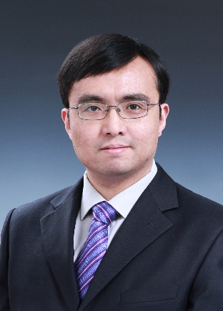
Hua Geng received the Ph.D. degree in control theory and application from Tsinghua University, Beijing, China, in 2008. From 2008 to 2010, he was a Postdoctoral Research Fellow with the Department of Electrical and Computer Engineering, Ryerson University, Toronto, ON, Canada. He joined Automation Department of Tsinghua University in June 2010 and is currently a full professor. He is an IEEE Fellow and an IET Fellow. He is also a Distinguished professor of Changjiang Scholars awarded by China Ministry of Education and the Chief Scientist of national key R & D program.

His current research interests include advanced control on power electronics and renewable energy conversion systems. He has authored more than 170 technical publications and holds more than 30 issued Chinese/US patents. He was granted the second prize of National Science and Technology Progress Award. He is the editors of IEEE Trans. on Energy Conversion and IEEE Trans. on Sustainable Energy, associate editors of IEEE Trans. on Industry Applications, IET Renewable Power Generation, Control Engineering Practice. He served as general chair/ co-chairs, track chairs and session chairs of several IEEE conferences. He is a convener of the modeling working group in IEC SC 8A, Standing Director of China Power Supply Society (CPSS).

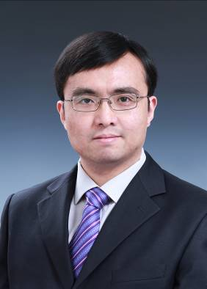
耿华 博士，清华大学长聘教授、自动化系党委副书记
2008年于清华大学自动化系获博士学位，2008.10-2010.5，在加拿大Ryerson大学从事博士后研究工作，2010.6至今，在清华大学自动化系从事电力电子与多能源系统相关教学科研工作。主持国家重点研发计划专项项目、国家自然科学基金重大集成项目课题、优青、重点、中英国际交流等科研项目；出版科学著作1部，发表论文170余篇；授权中国发明专利30余项；获国家科技进步二等奖1项、省部级科技奖励3项，当选教育部长江学者特聘教授、IEEE Fellow、IET Fellow。担任IEEE Trans. on Sustainable Energy等3个IEEE汇刊、Control Engineer Practice期刊编委，IEC国际标准工作组召集人，中国电源学会常务理事、青年工作委员会名誉主任、新能源电能变换技术专委会副主任，中国自动化学会电气自动化专委会副秘书长等。

报告题目：风电集群功率控制与优化
双碳目标驱动下，以风电为代表的新能源装备将成为未来电力系统的主要组成部分，不同于传统发电，风电机组的单机容量小、分布式布置，多机构成集群对外供电，传统发电的功率控制方法无法适用；因风电单机非线性强、多机功率耦合复杂，风电集群功率控制与优化面临巨大挑战。报告从风电集群功率控制需求出发，针对不同应用场景，分别介绍基于模型和数据驱动的风电集群功率控制与优化方法，并对未来研究进行展望。

